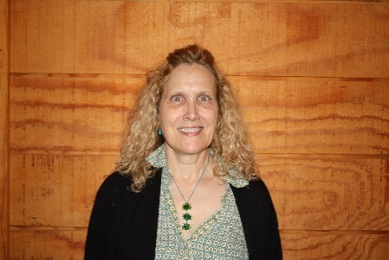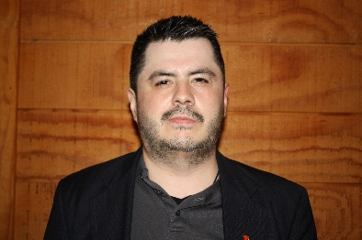Cabada, Elisandro

Alex

University of Illinois   
Urbana Champaign

Team: Green

cabada@illinois.edu

*participant*

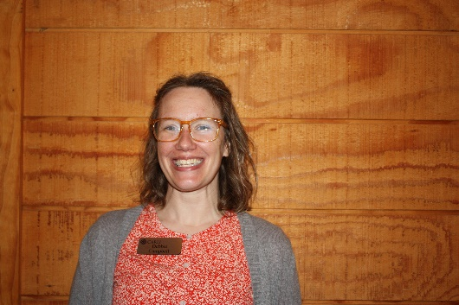

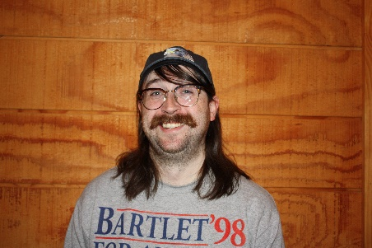Campbell, Deborah

Debbie

CARLI

dmcmpbll@uillinois.edu

*staff*

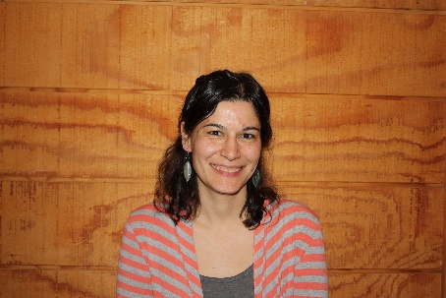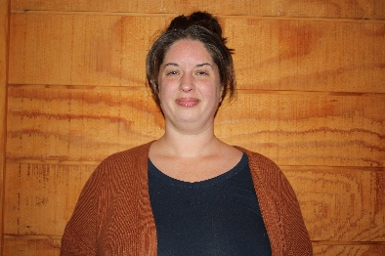Christensen, Sarah

University of Illinois Urbana Champaign

Team: Blue

schrstn@illinois.edu

*participant*

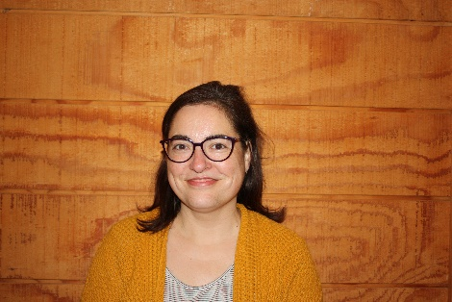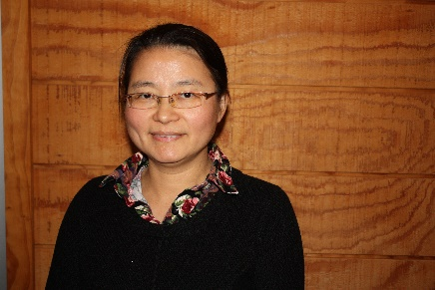Ciesla, Carolyn

Elmhurst University

Team: Green

carolyn.ciesla@elmhurst.edu

*mentor*

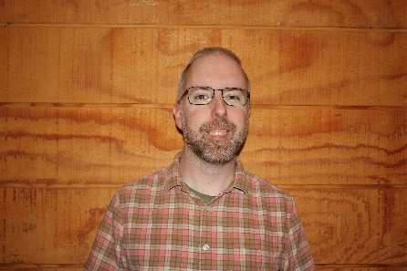

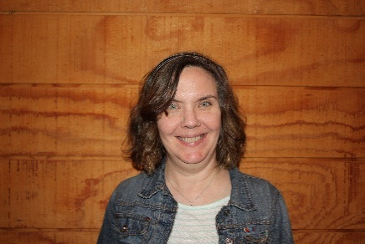Clark, Bryan

Illinois Central College

Team: Red

bryan.clark@icc.edu

*participant*

Craig, Anne

CARLI

abcraig@uillinois.edu

*staff*

Crawford, Tommy

Lake Forest College

Team: Blue

tcrawford@lakeforest.edu

*mentor*

Emersen, Maria

University of Illinois Urbana Champaign

Team: Red

memersn2@illinois.edu

*participant*

Feng, Yali

University of Illinois Urbana Champaign

Team: Blue

yalifeng@illinois.edu

*participant*

Figiel-Krueger, Maria

Rock Valley College

Team: Blue

m.figiel-krueger@rockvalleycollege.edu

*participant*

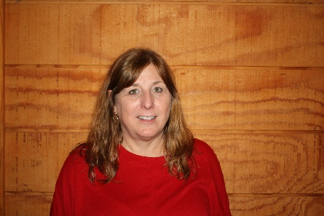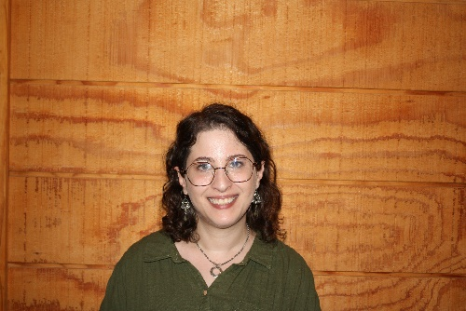Haake, Michelle

CARLI

mjhuls@uillinois.edu

*staff*

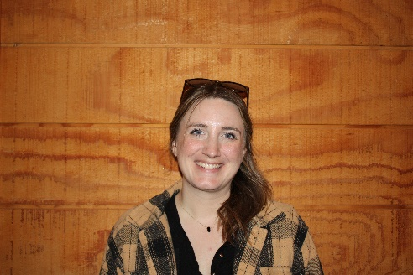

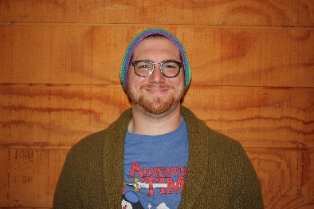Haas, Mitchell

Southern Illinois University Edwardsville

Team: Red

mhaas@siue.edu

*mentor*

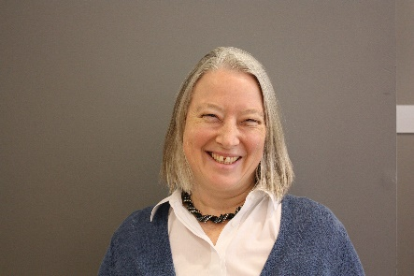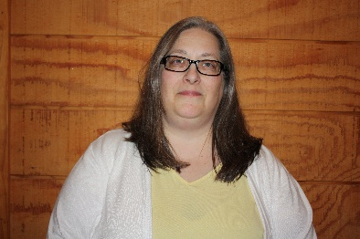Hinchliffe, Lisa

University of Illinois at Urbana-Champaign

ljanicke@illinois.edu

*staff*

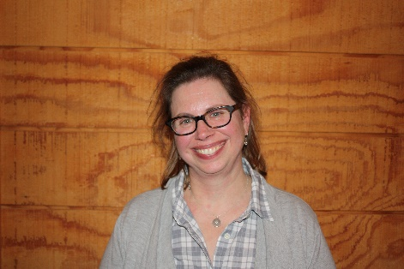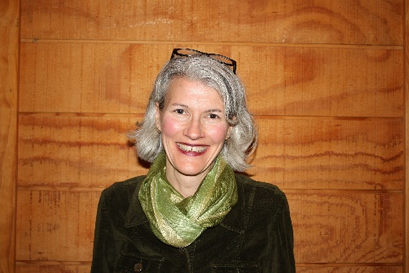Holschuh Simmons, Michelle

Western Illinois University

Team: Green

mh-simmons@wiu.edu

*participant*

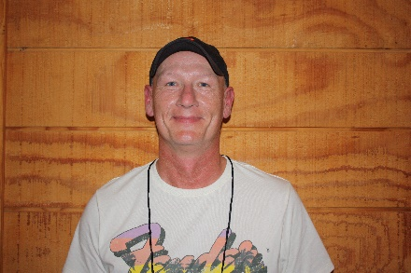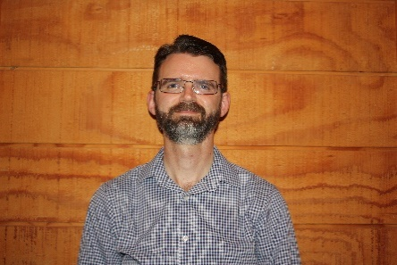Krieb, Dennis

Lewis & Clark   
Community College

dkrieb@lc.edu

*staff*

Levine, Sarah

Meadville Lombard Theological School

Team: Red

slevine@meadville.edu

*participant*

Nissen, Stephanie

Rockford University

Team: Red

snissen@rockford.edu

*participant*

Novak, Nichole

Illinois Institute of Technology

Team: Blue

nnovak2@iit.edu

*participant*

Odwarka, Amy

Eastern Illinois University

Team: Green

aodwarka@eiu.edu

*participant*

Rieckens, Derek

Catholic Theological Union

Team: Green

drieckens@ctu.edu

*participant*

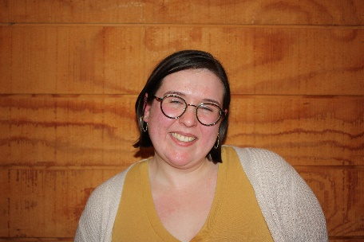Ringel, Charity

University of Illinois Springfield

Team: Red

cring4@uis.edu

*participant*

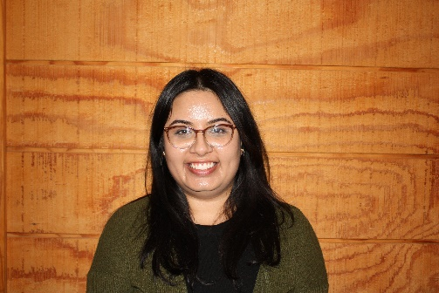Saulat, Zohra

Lake Forest College

Team: Green

zsaulat@lakeforest.edu

*participant*

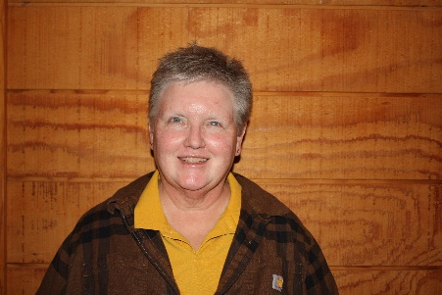Veldheer, Kris

Catholic Theological Union

Team:

kveldheer@ctu.edu

*MoM*

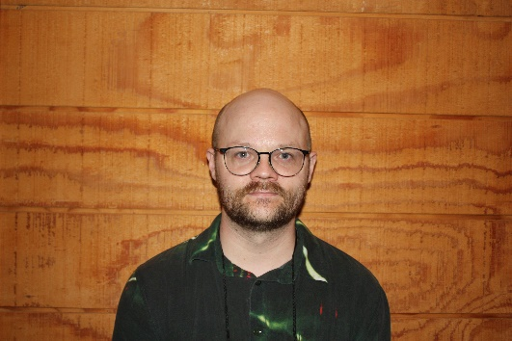Waites, William

Wills

Roosevelt University

Team: Blue

wwaites@roosevelt.edu

*participant*

**Blue Team**

**Red Team**

**Green Team**