Subject: Nexis Univ Linking Level in Alma/PrimoVE: ERMC Recommendations

To be sent to all 45 I-Share libraries with Nexis Uni currently active. List in separate document.

On August 25, 2022, Ex Libris Alma issued documentation about article-level linking and the Nexis Uni e-collection. The full article is at Alma: LexisNexis - removal of article-level linking for some collections (see section: “Article-level workaround for Alma/SFX via local override”).
The problem is that most Nexis Uni citations link to a “do a search for the article within the publication” type screen.
For example: Looking for this article in “Washington Technology” periodical:
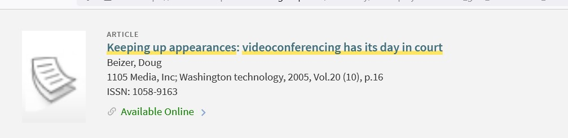
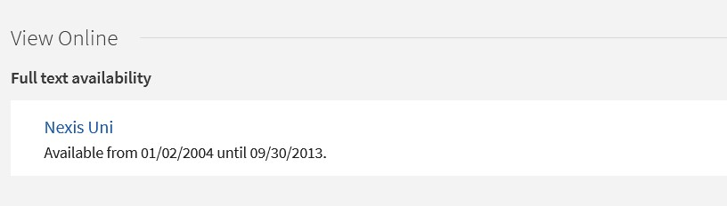
“Nexis Uni” link goes to: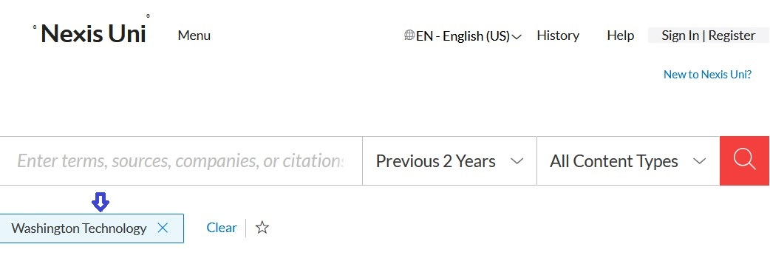

Basically, Ex Libris recommends adding ‘exception=use article' to the service level of the Nexis Uni e-collection. That makes the setting into:
Parser parameters (override):
URL=https://advance.lexis.com/api/search & exception=use article
The change is supposed to enable article level linking in some cases when Nexis Uni doesn’t modify the source citation’s title.

Recently the Electronic Resources Management Committee (ERMC) examined these recommendations and tried out the linking change. After extensive testing ERMC concluded:

- The workaround is easy to implement and to undo.
- However, the change does not improve linking for most citations to articles in full text Nexis Uni.
- Each I-Share library should decide whether to deploy this workaround.
- All I-Share libraries can add a public note at the Nexis Uni e-collection level that advises users to search by article title in Nexis Uni.
Example below from SIU Carbondale.

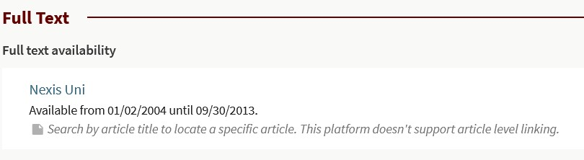

ERMC advises all I-Share Libraries with Nexis Uni active to consider whether to add this workaround or not.

Please send any questions to support@carli.illinois.edu

Thank you,

Denise Green

